LASI   
PUR, IGA

Family: gaussian

Link function: identity

Formula:

RW ~ SITE + YEAR + s(AGE)

Parametric coefficients:

Estimate Std. Error t value Pr(>|t|)

(Intercept) 0.9681026 1.2421505 0.779 0.436

SITEPUR 0.0095442 0.0690499 0.138 0.890

YEAR -0.0002050 0.0006432 -0.319 0.750

Approximate significance of smooth terms:

edf Ref.df F p-value

s(AGE) 5.896 5.896 4.758 5.92e-05 \*\*\*

---

Signif. codes: 0 ‘\*\*\*’ 0.001 ‘\*\*’ 0.01 ‘\*’ 0.05 ‘.’ 0.1 ‘ ’ 1

R-sq.(adj) = 0.0878

Scale est. = 0.1103 n = 7122

> summary(modlasiGamm$lme)

Linear mixed-effects model fit by REML

Data: strip.offset(mf)

AIC BIC logLik

1386.158 1454.861 -683.0788

Random effects:

Formula: ~Xr - 1 | g

Structure: pdIdnot

Xr1 Xr2 Xr3 Xr4 Xr5 Xr6 Xr7 Xr8

StdDev: 0.8223168 0.8223168 0.8223168 0.8223168 0.8223168 0.8223168 0.8223168 0.8223168

Formula: ~AGE | ID %in% g

Structure: General positive-definite, Log-Cholesky parametrization

StdDev Corr

(Intercept) 0.431588861 (Intr)

AGE 0.002829614 -0.888

Residual 0.332116426

Correlation Structure: ARMA(1,0)

Formula: ~YEAR | g/ID

Parameter estimate(s):

Phi1

0.6173344

Fixed effects: y ~ X - 1

Value Std.Error DF t-value p-value

X(Intercept) 0.9681026 1.2421505 7072 0.7793763 0.4358

XSITEPUR 0.0095442 0.0690499 46 0.1382218 0.8907

XYEAR -0.0002050 0.0006432 7072 -0.3187554 0.7499

Xs(AGE)Fx1 -0.2057906 0.1250881 7072 -1.6451649 0.1000

Correlation:

X(Int) XSITEP XYEAR

XSITEPUR 0.327

XYEAR -0.999 -0.353

Xs(AGE)Fx1 0.282 0.108 -0.284

Standardized Within-Group Residuals:

Min Q1 Med Q3 Max

-4.6708194 -0.5785305 -0.1045655 0.4353085 6.2008544

Number of Observations: 7122

Number of Groups:

g ID %in% g

1 48

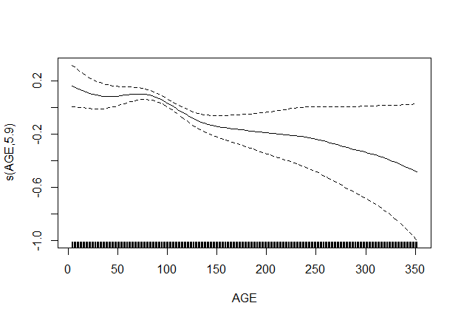

LACA

CHO, BIL

Family: gaussian

Link function: identity

Formula:

RW ~ SITE + YEAR + s(AGE)

Parametric coefficients:

Estimate Std. Error t value Pr(>|t|)

(Intercept) -0.6385367 0.3659462 -1.745 0.08103 .

SITECHO -0.2009936 0.0439043 -4.578 4.75e-06 \*\*\*

YEAR 0.0005187 0.0001809 2.868 0.00414 \*\*

---

Signif. codes: 0 ‘\*\*\*’ 0.001 ‘\*\*’ 0.01 ‘\*’ 0.05 ‘.’ 0.1 ‘ ’ 1

Approximate significance of smooth terms:

edf Ref.df F p-value

s(AGE) 7.827 7.827 10.97 <2e-16 \*\*\*

---

Signif. codes: 0 ‘\*\*\*’ 0.001 ‘\*\*’ 0.01 ‘\*’ 0.05 ‘.’ 0.1 ‘ ’ 1

R-sq.(adj) = 0.0062

Scale est. = 0.028102 n = 9872

> summary(modlacaGamm$lme)

Linear mixed-effects model fit by REML

Data: strip.offset(mf)

AIC BIC logLik

-9278.703 -9206.732 4649.351

Random effects:

Formula: ~Xr - 1 | g

Structure: pdIdnot

Xr1 Xr2 Xr3 Xr4 Xr5 Xr6 Xr7 Xr8

StdDev: 0.7395746 0.7395746 0.7395746 0.7395746 0.7395746 0.7395746 0.7395746 0.7395746

Formula: ~AGE | ID %in% g

Structure: General positive-definite, Log-Cholesky parametrization

StdDev Corr

(Intercept) 0.182813582 (Intr)

AGE 0.001992821 -0.853

Residual 0.167635760

Correlation Structure: ARMA(1,0)

Formula: ~YEAR | g/ID

Parameter estimate(s):

Phi1

0.4649128

Fixed effects: y ~ X - 1

Value Std.Error DF t-value p-value

X(Intercept) -0.6385367 0.3659462 9830 -1.744892 0.0810

XSITECHO -0.2009936 0.0439043 38 -4.577998 0.0000

XYEAR 0.0005187 0.0001809 9830 2.867624 0.0041

Xs(AGE)Fx1 -0.3582378 0.0772904 9830 -4.634957 0.0000

Correlation:

X(Int) XSITEC XYEAR

XSITECHO -0.735

XYEAR -0.996 0.708

Xs(AGE)Fx1 0.319 -0.198 -0.284

Standardized Within-Group Residuals:

Min Q1 Med Q3 Max

-4.41997891 -0.50492919 -0.09091433 0.37920481 17.43396918

Number of Observations: 9872

Number of Groups:

g ID %in% g

1 40

